**SIMULTAION MODELLING**

**Assignment 1**

*By Mohammed Nifaullah Sailappai (M13433497)*

**A. Traditional Perspective on the Problem**

Recommended Levels = 6

**B. Sensitivity Analysis**

NPV of Parking project is profitable when Demand Rate is at least 86%

**C. Randomizing the model and MCS**

*Questions:*

‐‐‐ Why is the average of the distribution of NPVs lower than the NPV in your original “Static

NPV” worksheet? After all, the demand variations are symmetric around the projections.

Static NPV is greater than the Average NPV because in the first instance we take a sure 100% demand whereas it is not the case for the approach here

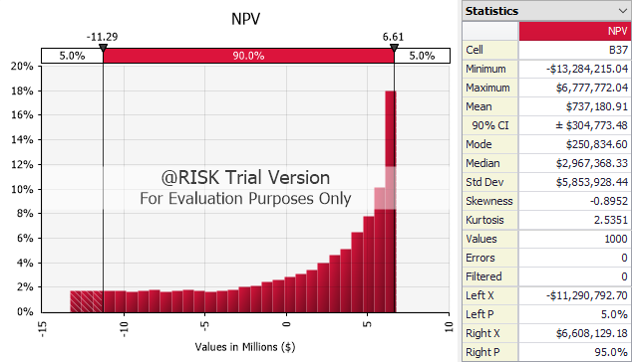

‐‐‐ What is the chance of losing money on the project?

There’s a 35% chance of losing money

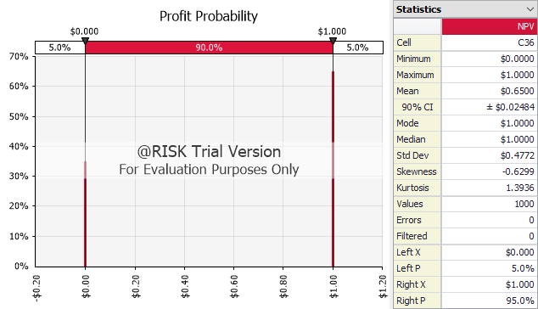

‐‐‐ Investigate the shape of the NPV distribution.

It is right skewed, some what like a inverse exponential distribution.

‐‐‐ Is that what you would have expected? Or would you have expected another shape? Can you

explain the shape?

Since we draw demand from uniform distribution, the expectation was also along the same line but it didn’t turnout as such. This may be due to the fact that after a certain point (at least around 50% of the time) Demand outgrew capacity. Hence the profit remained same even though demand grew.

**D. Re‐optimizing the number of levels**

After running MCS for different level it was realized that building a parking garage with 5 levels had the least amount of risk involved.

|  |  |  |  |  |  |  |  |  |  |  |
| --- | --- | --- | --- | --- | --- | --- | --- | --- | --- | --- |
| **Levels** | 1 | 2 | 3 | 4 | 5 | 6 | 7 | 8 | 9 | 10 |
| **Mean Profit Prob** | 0 | 0 | 0 | 0.5 | 0.68 | 0.636 | 0.604 | 0.519 | 0.406 | 0.348 |

**E. Valuing flexibility**

We can build 5 levels for the first 3 years and then increase as we move on.